**THRIFTY RETAIL STORE EVALUATION.**

**JANUARY 2018 – DECEMBER 2020**

**MARKET SEGMENTATION**

**Thrifty store data was collected from January 2018 -December 2020.**

The data contains features like

1. Customer details
2. Transaction data
3. Product information.

**General information of customers**

**What is the total number of transactions from 2018-2020?**

954012

**What is the number of unique customers from 2018-2020?**



**Age distribution**

* Number of customers based on Age groupings.

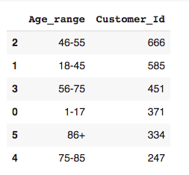

* Number of transactions based on Age grouping.

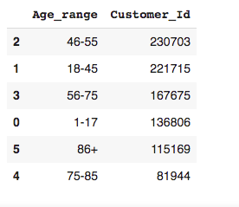

**Total Number of male and female customers**

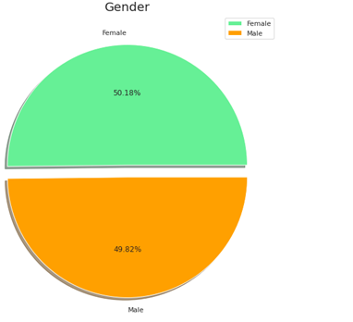

**Mode of purchase**

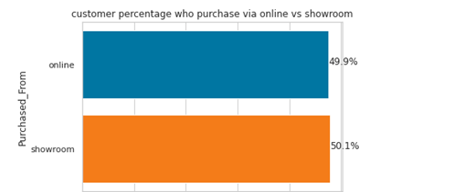

**PROFILING AND TARGETING CUSTOMERS**

Customer profiles (also known as buyer personas) are used to identify who your ideal consumers are. You may then develop marketing messages that target their problems and needs, attracting them to your company.

**CUSTOMER PROFILING PURPOSE**

The main goal of Customer Profiling is to

* Categorize the traits and characteristics of our customers,
* Identify the primary characteristics of good and bad customers.

**BENEFITS**

* Uncover which customers are sales and profit contributors.
* Identify customers who have profitable growth potential for the future.
* Discover who are your unprofitable customers.
* You can use the uncovered insights for development, customer service customization, media and channel selection, and targeting selection.

**THRIFTY STORE CUSTOMER PROFILING APPROACH**

* RFM Analysis
* Hierarchical clustering

**OUR DEFINATION FOR CLUSTERING.**

* Classification of our Customers into clusters depending on their similarity.

**How did we arrive at the number of clusters picked?**

The Silhouette Score and davis Bouldin for Hierarchical Clustering was used to determine the optimal number of clusters and dendrogram.

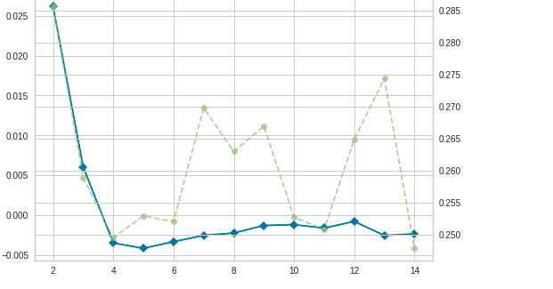

A visual representation of the dendrograms.

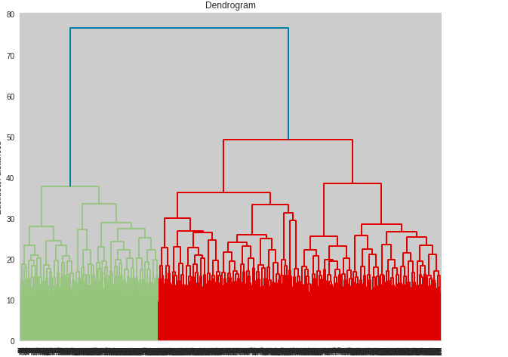

Also, after generating a scatter plot for different clusters, 2 clusters were a favourable pick because overlapping was minimized if you compared with the other clusters.

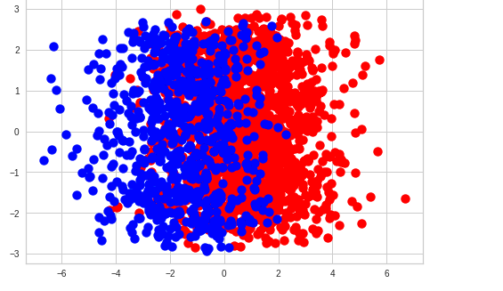

**WHAT IS RFM?**

**RFM**: Recency, Frequency, Monetary Value

RFM, is a method of segmenting customers on their buying behaviour.

RECENCY (R): Time since last purchase

FREQUENCY (F): Total number of purchases

MONETARY VALUE (M): Total monetary value

**FINDINGS ON CUSTOMER PROFILES**

**What does the two clusters mean?**

**Cluster 2**

Customers that are currently contributing the highest sales and profits.

**Cluster 1**

Group of customers with modest (or stable) growth potential

33% of the customers lie in cluster 1 and 67% of the customers lie in cluster 2.

All these customers in the same cluster possess similar characteristics when it comes to their purchasing patterns.

**Performance of the clusters in terms of where the customers in the two clusters are likely to purchase from**

Cluster 2 performs well across all the modes of purchase.

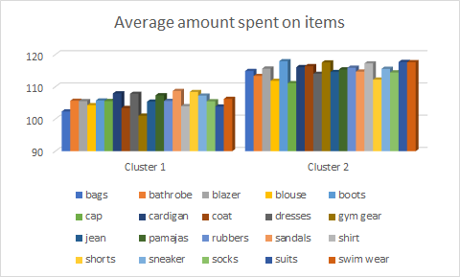

**AGE GROUPS IN THE TWO CLUSTERS**

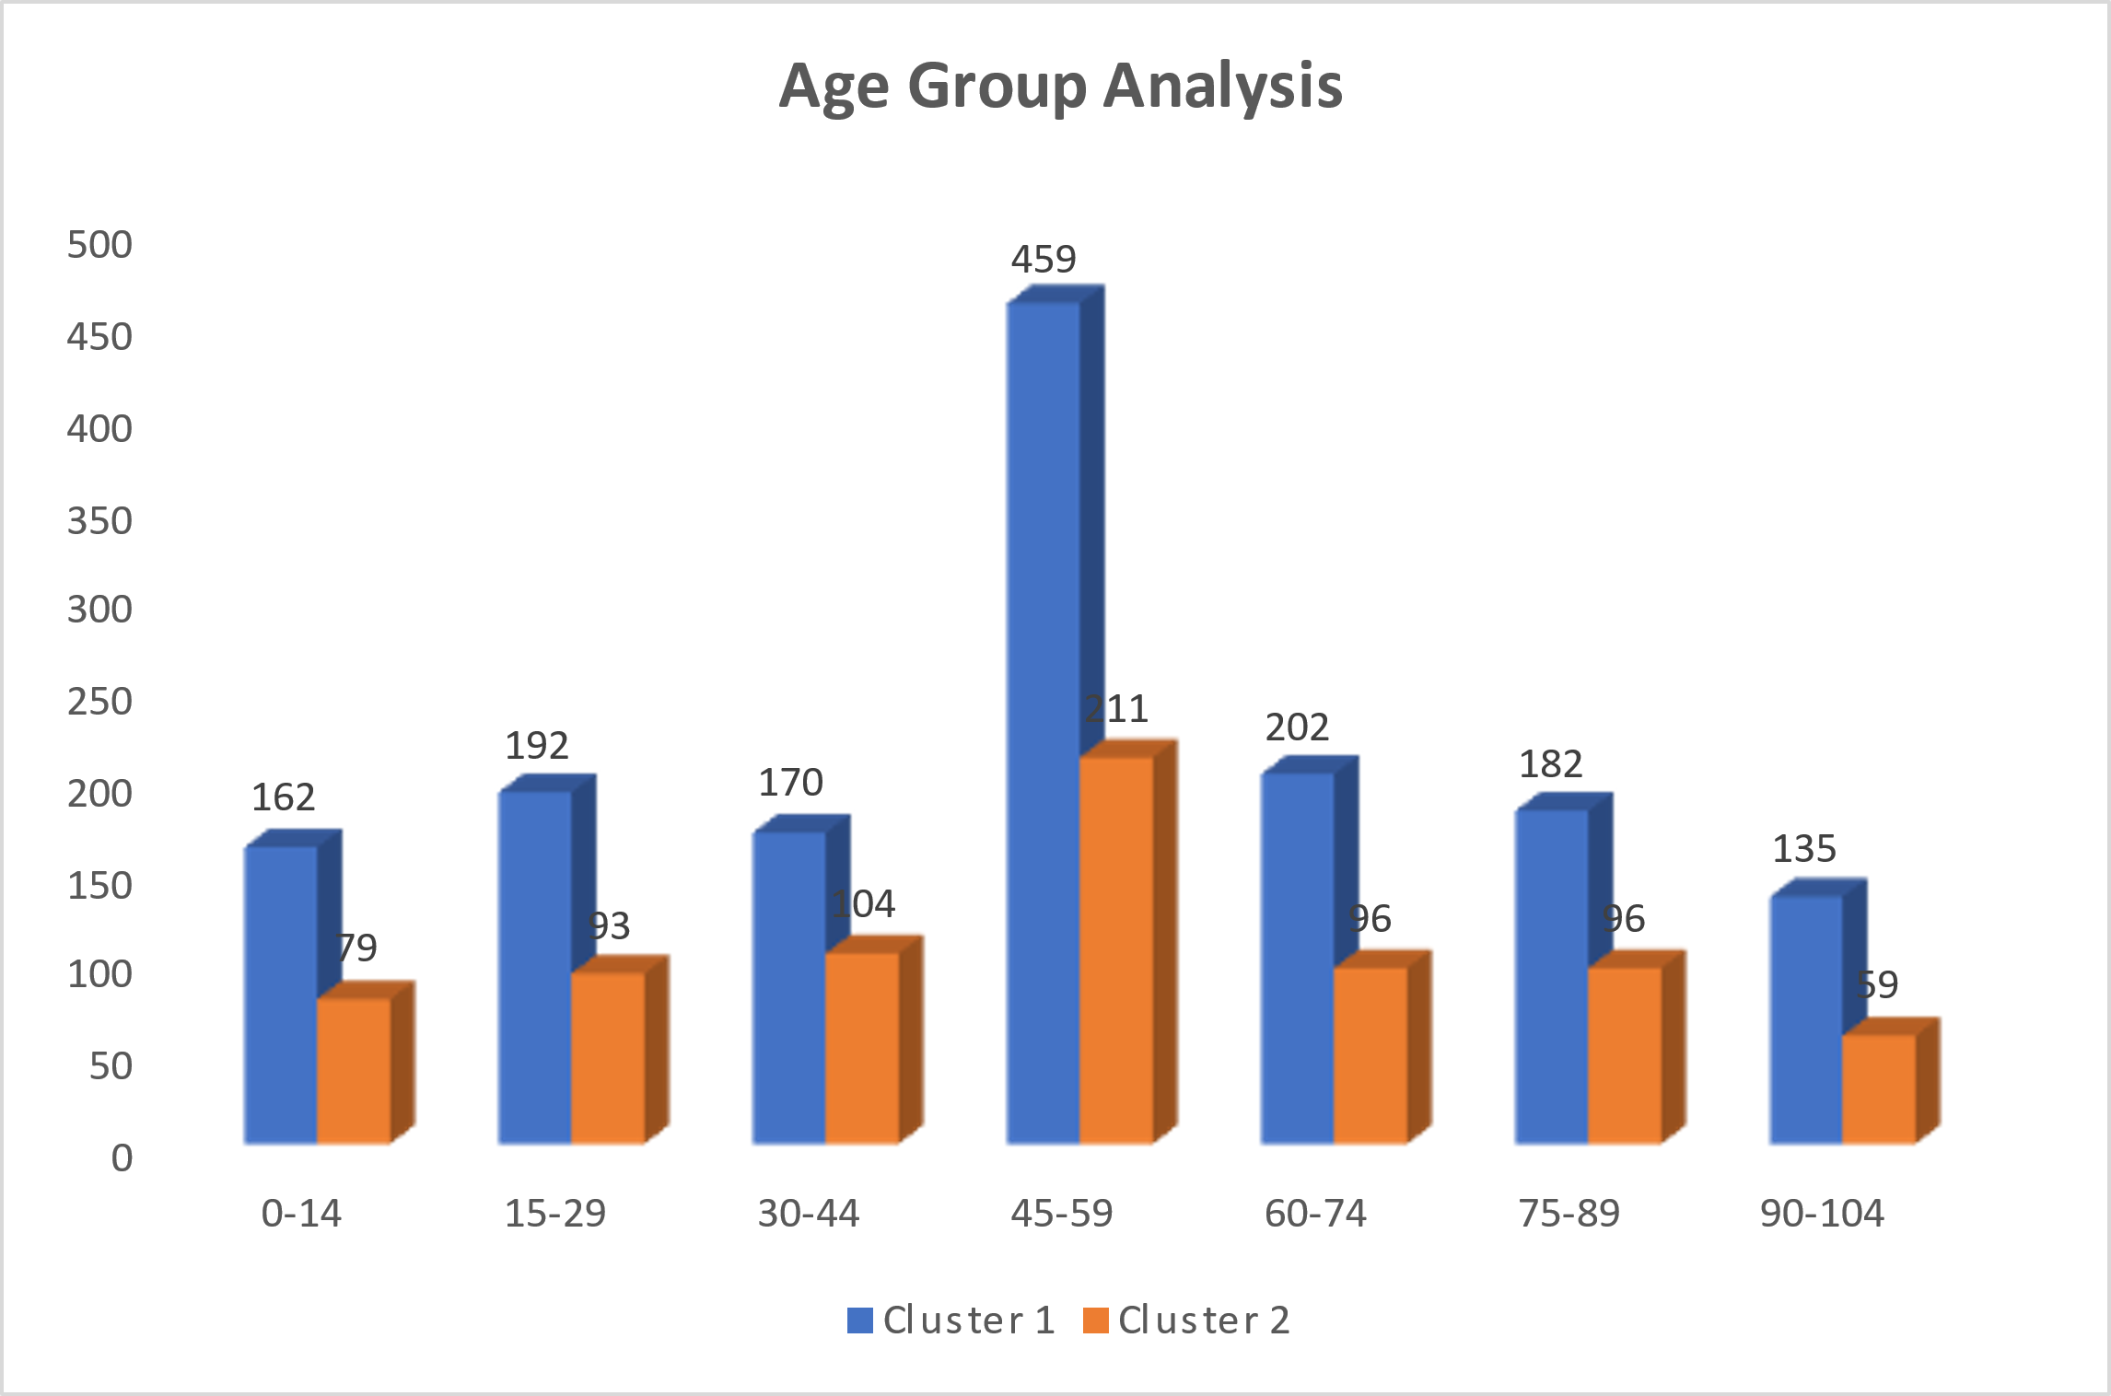

**GENDER GROUPING IN THE TWO CLUSTERS**

**OCCASIONS**

During some occasions cluster 1 which is generally the least performing cluster it outperformed cluster 2 the most performing cluster, holiday like Christi Himmelfahrt the average amount which was spent for cluster 1 was $732 and cluster 2 $647.

Also, cluster 1 performed well during Neujahr compared to cluster 2.

The amount spent on normal days proves the cluster 2 has the frequent customers.

The low spenders and risk to churn customers spend more when we have occasions compared to when we don’t have holidays.

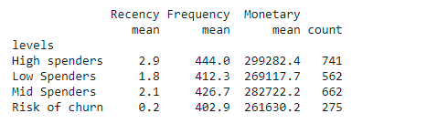

**RECOMMENDATION**

* Invest on retention of the 33% customers in cluster2 by giving them quality customer care, introduce occasional discounts to attract more purchases.
* Introduce occasional discounts to attract more purchases.
* During occasions introduce the most purchased items on those days and give discounts to encourage more sales